**public void forward(ServletRequest request, ServletResponse response)throws ServletException, java.io.IOException:**  
The forward() method is used to transfer the client request to another resource (HTML file, servlet, jsp etc). When this method is called, the control is transferred to the next resource called. On the other hand, the include() method is used to include the content of the calling file into the called file. After calling this method, the control remains with the calling resource, but the processed output is included into the called resource.  
The following diagram explains the way it works:

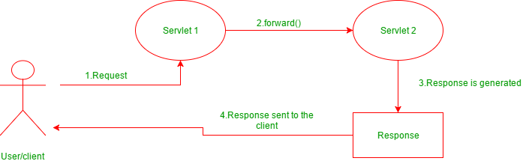

**public void include(ServletRequest request, ServletResponse response)throws ServletException, java.io.IOException:**  
The include() method is used to include the contents of the calling resource into the called one. When this method is called, the control still remains with the calling resource. It simply includes the processed output of the calling resource into the called one.  
The following diagram explains how it works:

